Aslan Oztreves

CS 383

Matthew Burlick

Homework #3

***Theory Problems***

1. Standardizing the data
2. Computer the weights by using

1. We have to take the derivate of the function g(x).
   1. , minima is x=1, checking the slope for both ends of 1, and find that it changes sign thus it’s going to come from negative to positive on the minima.
   2. Plotting x vs g(x)

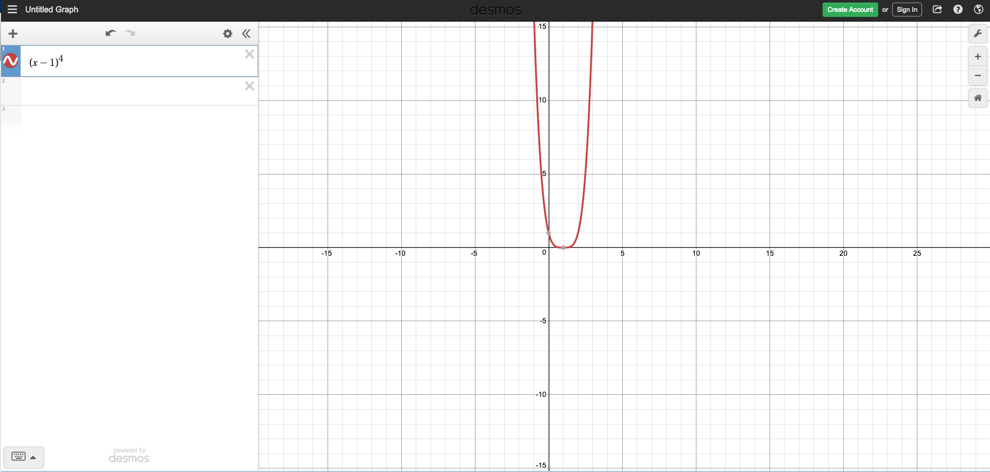

***Gradient Descent***

2.1.1) Plot Iteration vs g(x)

2.1.2) Plot Iterations vs x

2.1.3) Chosen value of n is 0.3.

2.2.1) Iteration vs g(x).

2.2.2) Iteration vs x

**Closed Form Linear Regression**

1. Formula
2. Values
   1. MSE = 7.2826e+05
   2. RMSE = 853.3806